LANGUAGE ARTS
2017-2018 SYLLABUS

CURRICULUM:
- Writing Coach
- Students will access electronic textbook through Pearson

SUPPLIES: Spiral Notebook (optional)

WRITING
6 Traits of Writing
- Ideas
- Organization
- Voice
- Word Choice
- Sentence Fluency
- Conventions
- Writing Process:
  - Brainstorming (Graphic Organizers)
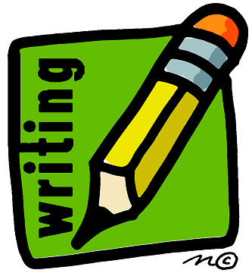
  - Drafting
  - Peer Editing/Critique Groups
  - Revising (RADAR)
  - Publishing (Final Draft)

Types of Writing/Essays
- Journaling (weekly)
- Narrative
- Creative
- Descriptive
- Argumentative
- Compare/Contrast
- Expository/Informative
- Research
- Poetry
- Blogging
- Figurative Language

STEMS
- Purpose: to build vocabulary
- Weekly (Lesson on Monday; Assignment due on Wednesday; Quiz on Friday)
- 6-8 Stem words each week
- Definition provided
- Students must find at least one word with a sentence and picture
- Eventually, spelling words will be included

STEMS RESOURCES:
www.morewords.com
www.affixes.org
www.wordinfo.info
www.learnthat.org/pages/view/roots.html

DAILY ORAL LANGUAGE (DOL)
- Daily editing/revision practice and application
- Must be handwritten (no typing)
- Mon-Thurs: “Bell-Ringer” Activity (sentence)
- Friday: Assessment (paragraph)

SENTENCE WRITING
- Subject/Verb Identification
- Simple Sentences (4 Levels)
- Compound Sentences (6 Levels)

PUBLIC SPEAKING/SPEECHES
- Improv
- Impromptu (20 seconds)
- Random Topic (2 minute)
- Informative (4-6 minutes)
- Debate (cooperative/small group format)

